**Working with Jenkins DSL**

* Jenkins DSL (Domain Specific Language) is written in Groovy Language
* Groovy makes easier for Creating DSLs and we can use the DSL without much experience with groovy.
* In this we will be looking at scripted pipeline

node ('GOL') {

stage('SCM') {

git 'https://github.com/asquarezone/game-of-life.git' # Step

}

}

* The node keyword is used to find the node on which the job can be executed
* stage clouser allows us to group individual steps which contains DSL commands and logic. Every stage needs to have a unique name
* With in the stage we write steps Relation b/w node, stage and steps 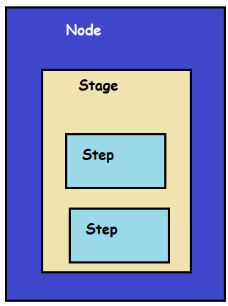
* Creating Jenkinsfile steps with snippet generator 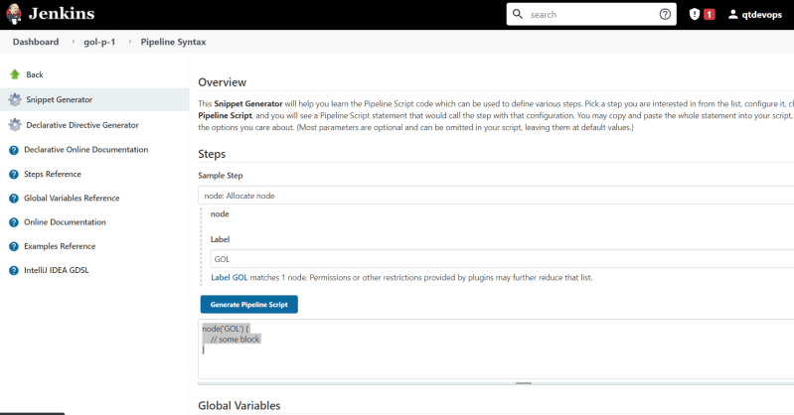
* We have created a scripted pipeline script to build the game of life

node('GOL') {

stage('scm') {

git 'https://github.com/asquarezone/game-of-life.git'

}

stage('build') {

sh 'mvn clean package'

}

stage('postbuild') {

junit '**/TEST-*.xml'

archive '**/*.war'

}

}

Exercise: Using the snippet generator create the Jenkinsfile for openmrs project

* + Fork the openmrs in your account
  + clone the repository into your system
  + Add a Jenkinsfile
  + IN the Jenkinsfile add scripted pipeline steps by using snippet generator